Application Requirements Specification

For

<Customer Management System>

Prepared By:

<Kehsin Yu>

* Purpose and Scope Statement

The purpose of this project is to create an application for managing customer information to improve the efficiency of information management in the company. The scope of this project includes adding, removing, updating, and viewing for customer information.

# Requirements Narrative

In this project, a customer management system will be created. In the system the user will have the following options:

1. Add a new customer information

When there is a new customer creating a new account, the user can use the system to add the customer information.

2. Remove an existing customer information

When a customer closes the account, the user can use the system to remove the customer information.

3. Update an existing customer information

When a customer needs to change the personal information, users can use the system to update the customer information.

4. View all customers’ information

Users can use the system to view all of the customers’ information.

5. Close Application

Users can exit the system.

# 

# Objectives

**Story Board for Customer Management System**

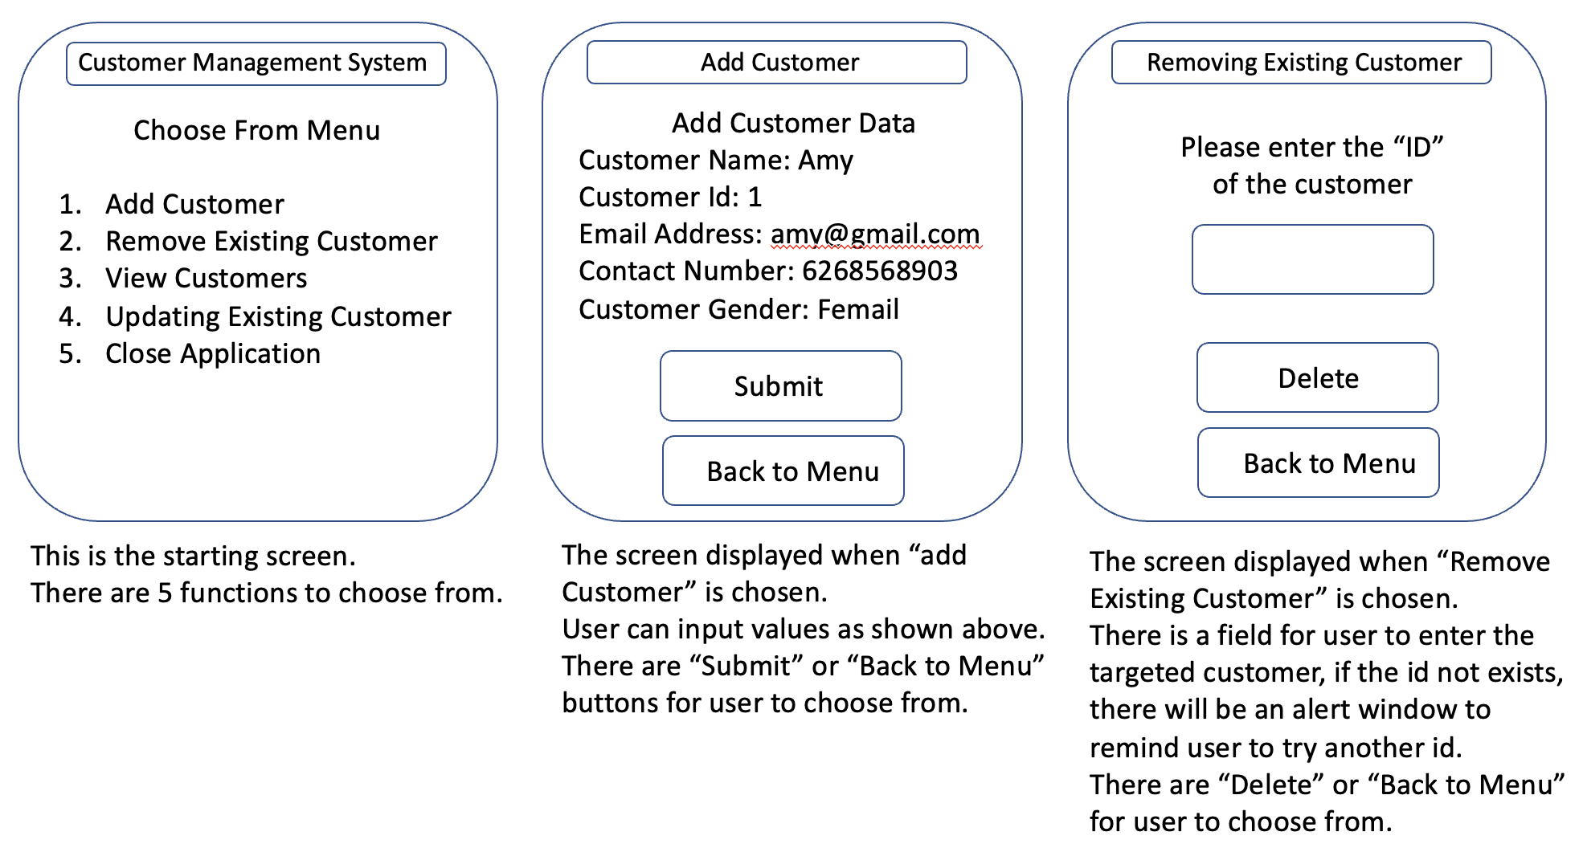

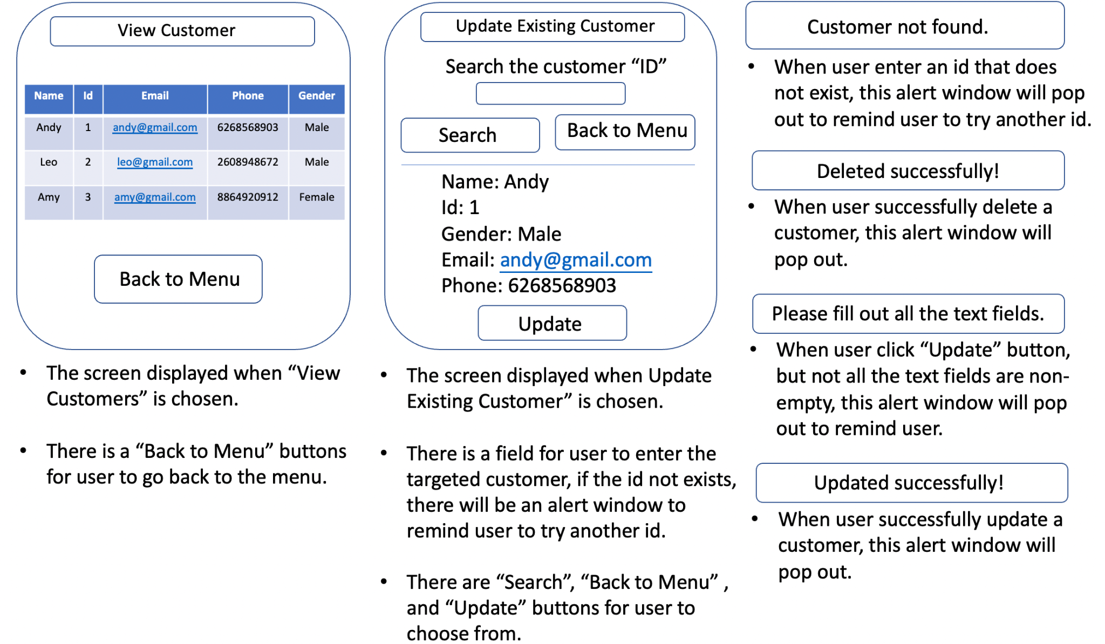

* Functional Specification

Classes:

1. Main.java

This class is for running the Customer Management System.

2. Menu.java

This class is for displaying the menu for the user to choose what the function to use.

3. Customer.java

This class is for adding a customer and handling the basic information for a customer. For example: name, id, email, phone, and gender.

4. RemoveCustomer.java

This class is responsible for removing existing customer information.

5. UpdateCustomer.java

This class is responsible for updating existing customer information.

6. ViewCustomer.java

This class is responsible for showing all existing customer information.

Objects:

1. Customer object including the following attributes:

String id

String name

String email

String phone

String gender

Java Libraries:

1. import java.util.Scanner;

handling user input

2. import java.io.*;

read and write file

3. import javax.swing.*;

the ui surface of the customer management system

* Logic Specification

**Visualization of the Flow of the Customer Management Module**

